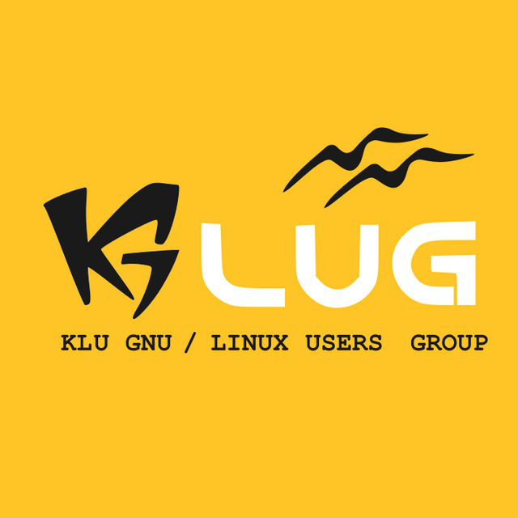

KLU GLUG MEET ON 06-09-2017

Session on Python :

Python is a widely used high-level programming language for general-purpose programming, created by Guido van Rossum and first released in 1991. An interpreted language, Python has a design philosophy that emphasizes code readability (notably using whitespace indentation to delimit code blocks rather than curly brackets or keywords), and a syntax that allows programmers to express concepts in fewer lines of code than might be used in languages such as C++ or Java. The language provides constructs intended to enable writing clear programs on both a small and large scale.
Python features a dynamic type system and automatic memory management and supports multiple programming paradigms, including object-oriented, imperative, functional programming, and procedural styles. It has a large and comprehensive standard library.

Python interpreters are available for many operating systems, allowing Python code to run on a wide variety of systems. CPython, the reference implementation of Python, is open source software and has a community-based development model, as do nearly all of its variant implementations. CPython is managed by the non-profit Python Software Foundation.

Session by:- Anusha and Srikanth

Students Attended:-
64 students attended the session on Python.

Classroom/Venue:- C109
